Rotary Club of Kathmandu Mid-Town
Breakfast Chatter




9 March 2012 The Weekly Bulletin of Rotary Club of Kathmandu Mid-Town Bc-3.09/011-12

District: 3292 Web: www.rotarymidtown.org.np Club Id : 26776

MARCH IS LITERACY MONTH
Teach children the value of life, and that they should respect others, no matter what sex or caste they belong to. If you can change their way of thinking, and introduce them to a better way of life,
you will be doing them and the entire community a great service.

2 March, Friday
Dr Niti Rana, who was scheduled to be the guest speaker for 2 March meeting, has been shifted to 16 March as per a request for change of the date.
Dikshya Chapagain agreed to be our guest speaker on short notice, and spoke about the work of Pabitra Samaj Sewa Nepal, an organization established for providing services to orphanage and for helping some old and homeless women. She also showed a brief video about her Samaj’s works.
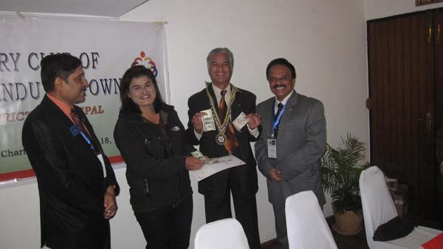
President Som and Rotarians from Bhubaneshwar handing over financial support to
Ms Dikshya Chapagain, Chairperson of Pabitra Samaj Sewa Nepa.
A certificate of appreciation was also given to her for her being the guest speaker.
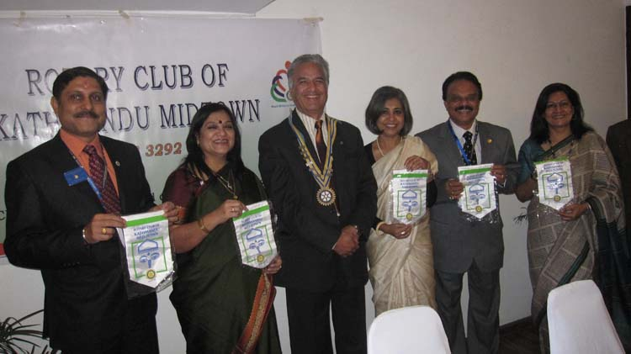
President Som presented club banners to 5 visiting Rotarians from Bhubaneshwar and Calcutta

Weekly Meetings and Programs :
Date | Program/Speaker | Program/Topics of Presentation
9 March 2012 | Rtr Samir Nepal | Rotaract/Rotary Collaborations: 2011/12 achievements
16 March 2012 | Dr Niti Rana | The Phenomenon of school bullying
23 March 2012 | Fionna Heiton | Play-based learning and child friendly teaching in schools
30 March 2012 | Archana Thapa | Alternative History: Women's Personal Stories

Rotary South Asia Conference on Literacy:
Rotary vows to end illiteracy, pledges to make all South Asians literate by 2017:
The three-day South Asia Conference on Literacy organized by Rotary International concluded here today with a series of pledges to eradicate illiteracy from the region by 2017.
Advisor of Rotary International Madhav Mohan said that there are about 99 million who are illiterate in the region. Each Rotary Club in the region are to take up the school adoption project by supporting schools to guarantee 100 percent literacy, partnership with stakeholders and particularly providing tablets – an integrated handheld device with self-learning software of audio-video pedagogy – to the illiterate. The school adoption program entails of infrastructure development in the existing schools, providing mid-day meals and training packages for the teachers in addition to the distance education.
Literacy became a focus for Rotary International since the South Asian Conference held last year in Colombo. RI Director Shekhar Mehta said that the move is similar to polio eradication initiative.
Source: The Himalayan Times

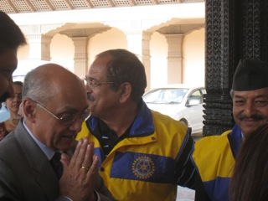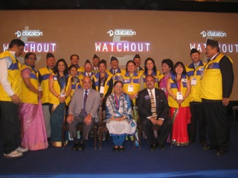
RIP Kalyan Banerjee being welcomed at The Sergeant-at-Arms Team with RIP Kalyan Banerjee and
Hyat Regency Hotel RID/Conference Convener Sekhar Mehta


Let’s not ever forget the small gestures that change lives. A pat on the back, a word of cheer,
sometimes just a smile is all it takes. And you will then see that almost everyone will smile
back. Laugh and the world laughs with you.
RI President Kalyan Banerjee

On Lighter Side : Click here ⇩


A thought for the day:
Cheerfulness and contentment
are great beautifiers and are famous preservers of youthful looks.
- Charles Dickens

Another worldly discovery: billions of other planets!
Astronomers said Wednesday that each of the 100 billion stars in the Milky Way probably has at least one companion planet, on average, adding credence to the notion that planets are as common in the cosmos as grains of sand on the beach. The finding underscores a fundamental shift in scientific understanding of planetary systems in the cosmos. Our own solar system, considered unique not so long ago, turns out to be just one among billions. Until April 1994, there was no other known solar system, but the discoveries have slowly mounted since then: The Kepler space telescope, designed for planet-hunting, now finds them routinely.
‘Planets are the rule rather than the exception,’ said lead astronomer Arnaud Cassan at the Institute of Astrophysics in Paris. He led an international team of 42 scientists who spent six years surveying millions of stars at the heart of the Milky Way, in the most comprehensive effort yet to gauge the prevalence of planets in the galaxy.
To estimate the number of other worlds, Dr Cassan and his colleagues studied 100 million stars between 3,000 and 25,000 light-years from Earth with gravitational micro-lenses. By their calculations, most of the Milky Way’s stars – 100 billion is the most conservative estimate – have one or more planets, the researchers reported in Nature.
Source: The Rising Nepal


Bulk transportation !

Please send project/activity information, suggestions and photos etc to :
BC Editor: RR Shrestha email: rryes@wlink.com.np

9 March 2012 The Weekly Bulletin of Rotary Club of Kathmandu Mid-Town bc-3.09/011-12

